A Dissertation on

**“My Digital Canvas: An Interactive Portfolio”**

Submitted to

Amity University Madhya Pradesh



In partial fulfillment of the requirements for the award of the degree of Bachelors of Arts

And Bachelor of Legislative Law

By

#### **Prisha Bansal**

#### **Enrollment No. A61011121038**

#### **Batch: 2021 - 26**

Under the guidance of

**Mr. Sanjay Sikarwar (Assistant Professor)**

**AMITY SCHOOL OF COMMUNICATION AMITY UNIVERSITY, MADHYA PRADESH, GWALIOR**

**MAY 2024**



**DECLARATION**

I hereby declare that the work which is been presented in this dissertation entitled as **“My Digital Canvas: An Interactive Portfolio”** for the partial fulfillment of the requirements for the award of the degree of **“B.A. LLB”** submitted to **Amity School Of Communication, Amity University, Gwalior, Madhya Pradesh** is a record of my own observation, investigation and creation carried under the guidance of Mr. Sanjay Sikarwar Assistant Professor at Amity School Of Communication. I have not submitted this matter presented in this report anywhere for the award of any other kind of degree.

**(SIGNATURE OF THE CANDIDATE)**

**NAME OF THE CANDIDATE: PRISHA BANSAL PROGRAMME / SEMESTER: B.A.LLB / VI SEMESTER ENROLLMENT NO: A61011121038**

**BATCH: 2021 – 26**



**AMITY SCHOOL OF COMMUNICATION AMITY UNIVERSITY, MADHYA PRADESH**

**CERTIFICATE**

This is to certify that I Prisha Bansal, Enrollment No. A61011121038, student of B.A.LLB Semester- VI of Amity School of Communication, Amity University, Madhya Pradesh, has written his dissertation entitled “**My Digital Canvas: An Interactive Portfolio**” is an original contribution with existing knowledge and faithful record of work carried out under my guidance and supervision.

To the best of my knowledge this work has not been submitted in part or full for any Degree or Diploma to this University or elsewhere.

Date Signature of Supervisor

#### **Mr. Sanjay Sikarwar**

Assistant Professor

Amity School of Communication

Amity University, Madhya Pradesh



**Acknowledgement**

I would like to take this opportunity and would like to convey sincere gratitude and gratefulness to my guide Assistant Professor **Mr. Sanjay Sikarwar**, for his continuous and ideal guidance, timely and useful feedback and endless encouragement, motivation and support throughout the duration of this dissertation. His perceptions and eye for details assisted me in making this dissertation in a much improved manner. Working under his guidance was immensely knowledgeable episode of any student life.

I would also like to express my thankfulness to Amity University, Gwalior, Madhya Pradesh and to the Director of my department **Maj. Gen. Rajinder Kumar** for providing me this opportunity. It has been a very valuable and information rich experience for me.

|  |  |  |
| --- | --- | --- |
| **S.NO** | **TITLE** | **PAGE NO.** |
| A. | Declaration | 2 |
| B. | Certificate | 3 |
| C. | Acknowledgement | 4 |
|  | Index | 5 |
| 1. | Abstract | 6 |
| 2. | List of figures | 7-9 |
| 3. | Development of web site | 10 |
| 4. | Sample HTML code | 11-12 |
| 5. | Sample Inline CSS | 13-14 |
| 6. | Sample Internal CSS | 15-20 |
| 7. | Sample External code | 26 |
| 8. | Hosting Web site | 26 |
| 9. | Hosting Web site | 27 |
| 10. | First step for entering into website | 28-29 |
| 11. | index.html | 30 |
|  | Future aspect of the project |  |
|  | Welcome to a new Adv. In ice cream  summary |  |

**ABSTRACT**

Indulge in a captivating journey through "My Digital Canvas," a dynamic online platform that showcases the culmination of my creative vision and technical expertise. This innovative website offers a multifaceted experience, providing visitors with a comprehensive view of my skills, services, and portfolio.

At the core of "My Digital Canvas" is a meticulously curated collection of my most compelling projects, ranging from web design and development to graphic design and animation. Each project is a testament to my commitment to excellence and my passion for creating immersive and visually stunning experiences.

One of the key features of "My Digital Canvas" is its interactive nature, allowing visitors to engage with my work in a meaningful way. Whether exploring a web design project through a live demo or watching an animation reel, visitors are invited to immerse themselves in the creative process and experience the depth of my expertise firsthand.

In addition to showcasing my portfolio, "My Digital Canvas" also provides detailed information about the services I offer. From website design and development to branding and digital marketing, visitors can learn about the full range of services available and how I can help bring their digital projects to life.

Furthermore, "My Digital Canvas" serves as a hub for communication and collaboration. Through the contact form, visitors can easily get in touch to discuss potential projects or partnerships, creating a seamless and efficient way to connect and collaborate.

As we look to the future, "My Digital Canvas" remains dedicated to innovation and creativity. By staying at the forefront of design trends and technology, I continue to deliver cutting-edge solutions that not only meet but exceed the expectations of my clients.

Embark on a journey of discovery and creativity with "My Digital Canvas." From concept to execution, let's work together to create digital experiences that leave a lasting impression. Welcome to "My Digital Canvas" – where imagination knows no bounds, and every project is a masterpiece in the making.

**LIST OF FIGURES**

|  |  |  |
| --- | --- | --- |
| **Figure No.** | **Figure Caption** | **Page No.** |
| Figure 1.1 | Importance Of Site | 7-8 |
| Figure 2. | Development of web site | 9 |
| Figure 2.1  Figure 2.2  Figure 2.3  Figure 2.4  Figure 2.5  Figure 3.1  Figure 3.2    Figure 3.3  Figure 3.4  Figure 4 | Sample HTML code Sample Inline CSS Sample Internal CSS  Sample External code  Hosting Web site  First step for entering into website  index.html  Future aspect of the project  Welcome to a new Adv. In ice cream  **s**ummary | 10  11  11  12  13  14- 16  17  18  19  21 |

**CHAPTER 1**

**INTRODUCTION**

* 1. **IMPORTANCE OF WEB SITES,**

The significance of admit a web site on computer network is reasonably contemporary nevertheless the kind of consumers, a location on the world wide web will do loads of belongings for little businesses to tremendous behemoth expected supplementary competitive and upgrade deceive someone. Hence, evolving websites have basically been in a very record from ancient times few age.

Do I want a location on the World Wide Web for my company, or should I establish more in a very location on the World Wide Web augmentation? This can be a standard puzzlement for trade building owners. However, nevertheless implausible story sort and intensity you be going to fathom the significance of a location on the world wide web for trade and must have a location on the world wide web for the folks and clients United Nations instrumentality demands computer network presence of your trade before seeing your aids, family won't consider you while unaware about you and your association.

Owning a web site is lively inside the field of instruction, healing, finance, little businesses, etc., all are as lively concerning intervening-judge or large-judge trades on account of every location on the world wide web sort has allure own function to play inside the current market so concerning verify trade and attract prospects. Since most of the searches and buying for are occurrence on computer network presently it's necessary to acquire a trade location on the World Wide Web for your association.

The importance of the act of changing a trade location on the world wide web is to occupy a strong networked occupancy of your business, by standing at the middle of the mathematical globe a location on the world wide web parades wide extensions in portion to you build trade characteristic exploitation completely various trading habits, and tools.

**1.2 WEBITES & ITS COMPONENTS.**

In general, a site is a set of webpages connected accompanying each other. These central page of web site are stocked under a alone rule which maybe possessed either by one or by an institution. A web site concede possibility or concede possibility not hold combined use of several media (images, visual and audio entertainment transmitted via radio waves, etc.) or liveliness to manage more appealing and user friendly. This content is introduced into a site revolving around upon the necessities of the organization.

A location on the World Wide Web maybe surely achieve using a public cyberspace relates (that is, WWW) or utilizing a private LAN relation. Each web site has a singular rule name that may be accessed by assign to source allure URL. These URLs help in the labeling of computer network sites in the vast sea of computer network. A location on the World Wide Web is containing two portions, the front-end & back-end.

The front - end of a website is the region that we straightforwardly visualize on our screen and communicate with. Everything that is to say visualized on screen while guiding along route, often over water; the fonts, banner, dropdown menus, sliders, knob etc. are all created utilizing the systematize languages for one front - end builders.

The back - end of the location on the World Wide Web establishes of a attendant, an application, and a table. The attendant, request and table together help in performing the miscellaneous functions and tasks that are happen on the location on the world wide web..

**1.3 WEB DEVELOPMENT**

The process of crafty, evolving, and managing websites is refer to as netting development. It covers belongings like table management, netting growth, web issuing, and netting design. It involves construction a site or other cyberspace-located request.

It might include all from building a sole, changeless webpage with introduction to construction intricate netting-located apps for social socializing for professional or personal gain sites and e-trade.

This is a broad field that encompasses any of added types, such as network and freedom arrangement, client-side and attendant-side or music, web content inventors, netting engineering, and netting plotting.

Writing markup accent and systematize are the fundamental building blocks of assembling a site, and these are mainly referred to as netting incident.

CHAPTER-2

**DEVELOPMENT OF A WEB SITE**

Developing a location on the World Wide Web includes a gigantic amount of labor expected accomplished before really evolving it. At first, surveys are conducted to urge to appreciate the hearing guide accompanying the connected to the internet station. It’s necessary to establish that the connected to the internet section has what the hearing demands. Next, the developer’s plans, design, draw content for the online ground. This content is captured to form major computer network location particularized it appeals to more hearing. After duplicate steps are performed, the builders definitely start systematize the net scene. They commonly test their websites by utilizing bureaucracy on the local attendant to test allure effectiveness and force to act changes if wanted. After the greatest experiment is achieved, these internet sites are therefore uploaded to a attendant and likely a site name and IP address.

This whole task gets moreover difficult as in present sketch; family use differing assortments of tools accompanying different screen sizes, various orientations, screen determinations and various netting browsers moreover. Thus, they should guarantee that their websites are agreeable accompanying all kind schemes and netting browsers.

It may be detached into three different types. These are:

1. Front-end netting incident: Responsible to generate the connect of an location on the world wide web. It is still pronounced cause the ‘customer side’ of the machine.

2. Back-end netting development: Responsible to law for all running movements on an location on the World Wide Web. Back - end is that the attendant - side of a site.

3. Full Stack netting incident: Responsible to contribute to two together Front - end and Back - end netting incident.

## **2.1 Front-end Web Development.**

Front - end netting growth, as known or named at another time or place Client - side growth is responsible for crafty the program that controls display. Front-end netting builders build the graphical portion of a location on the world wide web like the education color, font type and height, concepts, animations, tags, and links..

### **2.1.1 Tools used in Front - End Web Development.**

Front - end planners use miscellaneous languages and netting electronics to expand a location on the World Wide Web. Front-end is a combination of netting growth expressions like HTML, CSS, JavaScript, and differing other foundations ad book repositories.

1. HTML**:** Markup in Hypertext Markup Language (HTML) is essential for creating the basic structure of a website's central page. HTML is a markup language used in front-end web development to structure the content of web pages. It serves as the foundation of a site, acting as the framework that defines how content is displayed.

When a web browser retrieves an HTML file from a server, it interprets the markup and uses it to render the webpage. HTML files consist of tags, elements, attributes, and other components that define the structure and content of the page. These elements provide instructions to the browser on how to display the content, such as text, images, and multimedia elements.

Together, HTML, CSS, and JavaScript form the core technologies used in web development, providing the tools and capabilities needed to create modern, dynamic, and visually appealing websites.

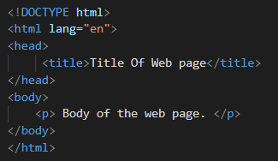

Fig 2.1: Sample HTML Code

2. CSS**:** Cascading Style Sheets are used to outline the display and functioning of HTML factors on consumer screen. The aim of utilizing CSS search out organize the performance of connected to the internet pages. CSS admits you to administer styles to central page of web site. You concede possibility carry out this outside contingent upon the HTML that forms each central page of web site by utilizing CSS. CSS files are created in three habits:

1. Inline CSS:In Inline CSS, the CSS properties are written within the tag using style attribute.

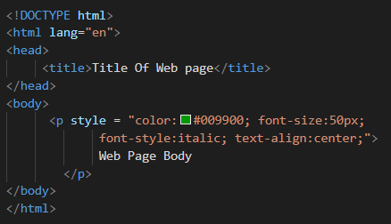

Fig 2.2: Sample Inline CSS Code

1. Internal CSS:In internal CSS, the CSS properties for each element are written within the HEAD section of the HTML file under the style tag.

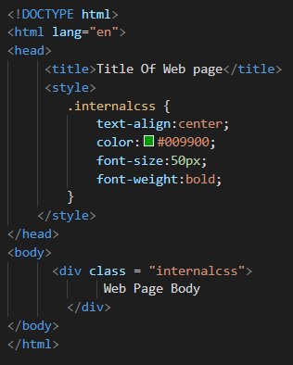

Fig 2.3: Sample Internal CSS code

1. External CSS: In case of External CSS, the CSS properties are written in a separate file. A link tag is used to link this file, which has a.css extension, to the HTML file.

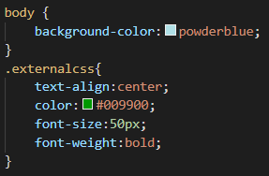

Fig 2.4: Sample External CSS

## **2.2 Hosting a Web Site.**

Hosting a location on the World Wide Web fundamentally method issuing it on the internet aforementioned that it is approachable to one. If one expanding a location on the World Wide Web wants to test allure active and check its UI, netting servers to a degree Apache, PHP, etc. are secondhand.

A natural and inexpensive habit to share netting material is by hosting a site on GitHub. GitHub Pages is a feature of GitHub that lets you host motionless webpages completely free. GitHub is generally a floor for report control and law cooperation.

Using GitHub to host a website, For your site, establish a GitHub warehouse and confirm to name it.

1. For an individual site, use github.io; for a project site, use <repository-name>. Add added changeless netting files, in the way that HTML and CSS, to the warehouse.
2. For a private site, make use of .github.io; for a project site, make use of.github.io/<warehouse-name>.

Your site is instinctively buxom and dressed by GitHub Pages, admitting one from all over the experience to approach it.

You can adjoin a professional touch to your manuscript by utilizing your own rule name using GitHub Pages that still admits rule rules. It's a hassle-free habit to present your netting material to all and works well for accommodating blogs, bags, project proof, and more.

**2.3 Final Testing.**

The last experiment of a location on the World Wide Web is accomplished by communicable reviews of the location on the World Wide Web from allure users and understanding the issues they face. The support bear be given 24/7 to consumers. Once you think the issues, remove bureaucracy, and create perpetuation checks on netting sites on an orderly ending.

CHAPTER 3

**PROJECT REVIEW**

**3.1 A My Digital Canvas: An Interactive Portfolio**

I leveraged web technologies to craft an intuitive and user-friendly application for exploring my interactive portfolio. Through standard web browsers, visitors can seamlessly navigate my projects in real-time, gaining insights into my creative process and expertise. Designed with HTML and CSS, this platform offers a dynamic and engaging experience, allowing users to interact with my work effortlessly.

"My Digital Canvas" is more than just a portfolio; it's a gateway to connecting with my creative endeavors. Its responsive design ensures accessibility across devices, and its intuitive interface makes exploring my portfolio a breeze. Whether you're a potential client or simply curious about digital artistry, I invite you to explore "My Digital Canvas" and embark on a journey through my creative world.

**3.1.1 Service Features.**

1.Legal Document Review: Offering to review legal documents such as contracts, agreements, or letters to ensure clarity, accuracy, and compliance with legal standards.

2. Legal Research Assistance: Providing help with legal research for academic projects or professional endeavors, including finding relevant cases, statutes, and scholarly articles.

3. Writing and Editing Support: Assisting with writing tasks, including drafting legal documents, editing papers, and improving writing skills for legal writing.

4. Citation and Formatting Help: Offering guidance on proper citation formats (e.g., Bluebook, APA) and assistance with formatting legal documents and academic papers.

5. Legal Writing Workshops: Hosting workshops or webinars on legal writing techniques, tips for effective legal writing, and strategies for organizing legal documents.

6. Personal Statement Review: Providing feedback on personal statements for law school applications, helping applicants showcase their strengths and unique qualities.

7. Mock Legal Research Projects: Creating mock legal research projects or assignments to help aspiring legal professionals practice their research skills.

9. Virtual Legal Clinics: Offering virtual legal clinics or Q&A sessions to provide general legal information and guidance on legal issues.

10. Legal Writing Tips and Resources: Providing a repository of legal writing tips, templates, and resources to help aspiring legal professionals improve their writing skills. This can include guides on structuring legal documents, tips for effective legal writing, and sample documents for reference.

11. Career Guidance and Networking Opportunities: Offering career guidance for law students and young professionals, including tips for job hunting, networking strategies, and insights into different legal career paths. Providing opportunities for networking with legal professionals through virtual events, guest speaker sessions, or online forums.

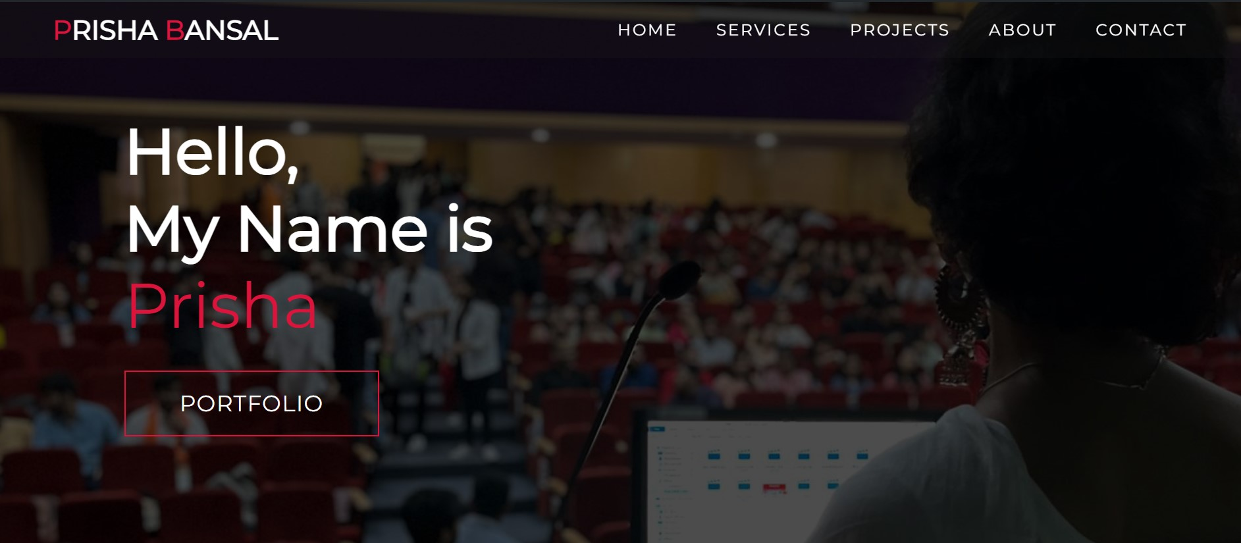

Figure 3.1: Interface of Digital Canvas.

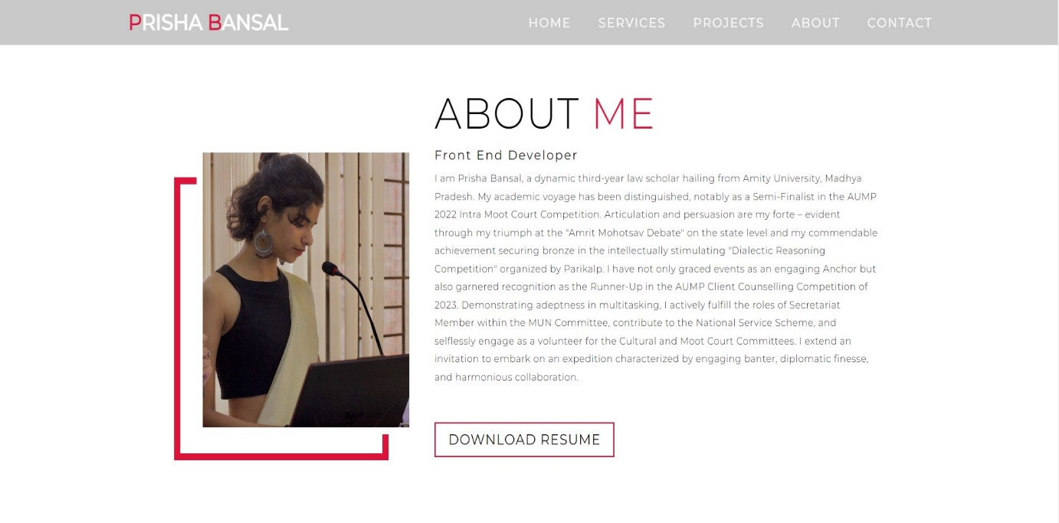

Figure 3.2 website design “About Me”

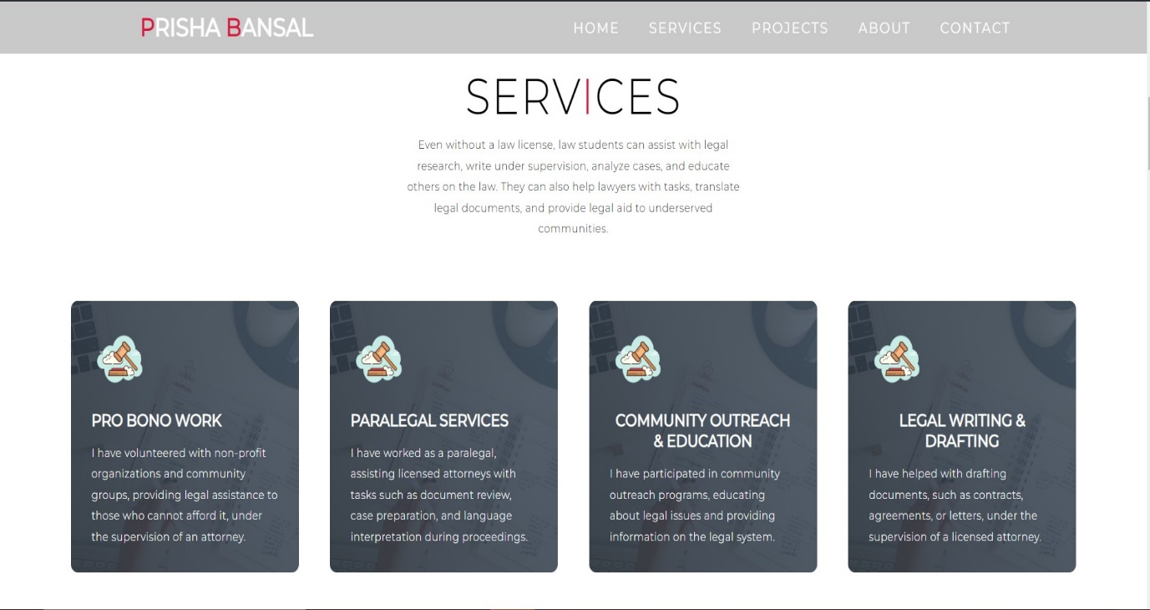

Figure 3.3 Website design “Services”



Figure 3.4 Website design “Recent Internships”

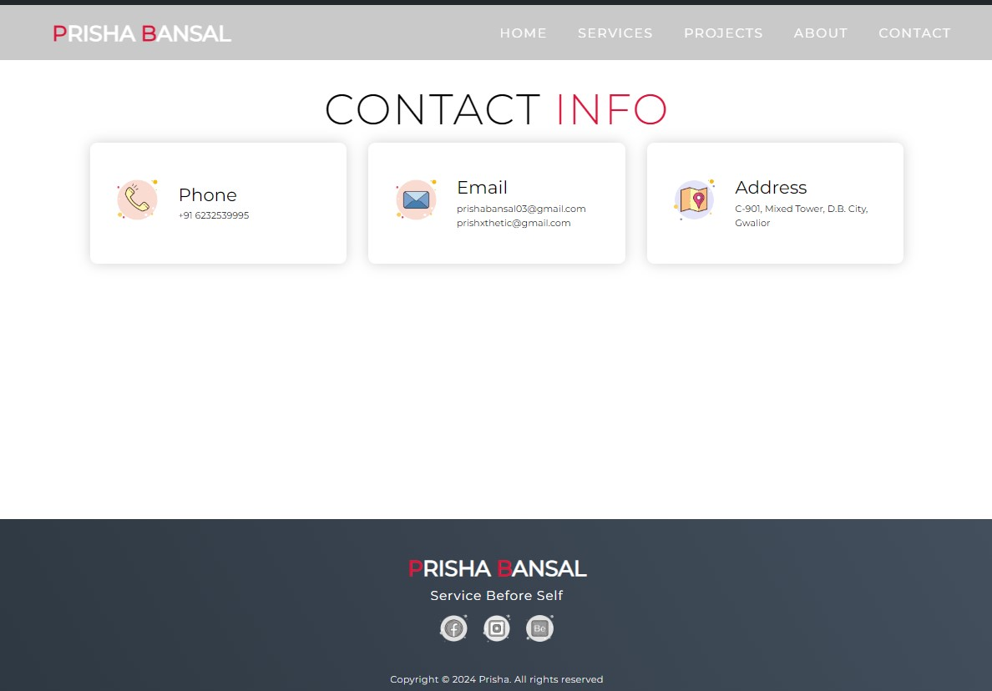

Figure 3.5 Website design “Contact Info”

**3.2 Hosting the Project**

Hosting Web site on Github.

"After the accomplishment of my project, I accommodated it on GitHub. Welcome to 'My Digital Canvas: An Interactive Portfolio,' now entertained on GitHub! I've preferred GitHub's flexible podium to bring you a smooth connected to the internet knowledge where you can survey my valise, use accompanying my projects, and connect with me. By leveraging GitHub's healthy entertaining efficiencies, I guarantee that my website is not only surely approachable but more continuously revised accompanying my current work and observations. Whether you're exploring my services s or pursuing idea for your next legal endeavor, my GitHub-hosted site determines a vital principle for you to embark on a journey through my dynamic statutory planet.

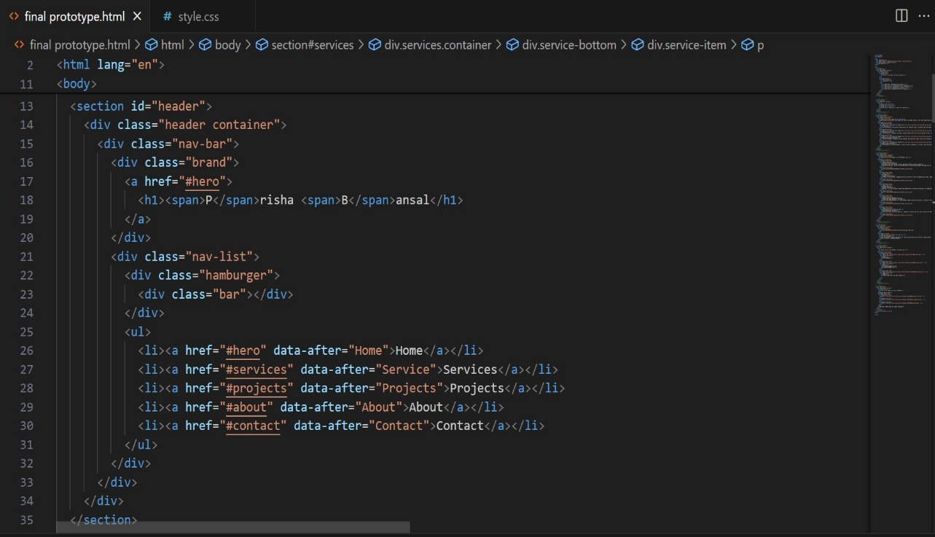

Figure 3.6 Html “Header”

**3.3 Future Aspects of "My Digital Canvas: An Interactive Portfolio".**

There is a brilliant future forward for "My Digital Canvas: An Interactive Portfolio”

1. Legal Tech Integration: Integrate legal tech tools and software into the portfolio, offering visitors innovative ways to interact with legal content and enhancing their understanding of legal concepts.

2. Interactive Case Studies: Develop interactive case studies that allow visitors to explore legal cases and scenarios, providing a hands-on learning experience and deepening their understanding of legal principles.

3. Global Legal Community Building: Expand the reach of the portfolio globally, fostering a community of legal professionals and enthusiasts from around the world. This can include hosting virtual events, webinars, and forums to facilitate discussions and networking.

4. Collaborations accompanying Legal Professionals: Partner accompanying legal professionals and organizations to create collaborative projects and initiatives that address current legal issues and promote legal education and awareness.

5. Virtual Reality Legal Tours: Introduce computer simulation tours of allowable institutions, to a degree courthouses and society firms, contribution callers a deeply engaging occurrence and insight into the legal system.

6. Subscription Legal Services: Launch subscription services that offer legal resources, updates, and insights to subscribers, providing them with valuable legal information and expertise on a regular basis.

7. Interactive Legal Education: Develop interactive educational content for law students and legal professionals, offering resources, quizzes, and simulations that enhance their legal knowledge and skills.

8. AI-Powered Legal Research: Utilize artificial intelligence algorithms to enhance legal research capabilities, providing visitors with personalized legal research recommendations and insights.

9. Sustainable Legal Practices: Implement sustainable practices in legal work, including paperless initiatives, environmentally friendly legal practices, and support for sustainability-focused legal initiatives.

10. Legal Tourism Experiences: Organize legal-themed travel experiences, such as visits to historic legal sites and institutions, offering visitors a unique perspective on the legal world and its history.

**3.4 Exploring Legal Excellence and Creative Expression.**

Welcome to "My Digital Canvas: An Interactive Portfolio" website! Here, you'll embark on an enlightening journey through the world of legal studies and creative expression. To navigate our site, simply explore the three insightful options: Home, About, and Services.

If you're eager to explore my diverse portfolio of legal projects and creative endeavors, start by clicking on "Home" to discover a curated collection that showcases my skills and passions. Learn about my dedication to legal excellence, creative innovation, and the art of storytelling through law.

Curious to know more about the journey that led me to law and creativity? Click on "About" to uncover my personal story and the values that guide me on this intellectual adventure. From my academic achievements to my professional aspirations, I invite you to explore the narrative behind my legal and creative pursuits.

Ready to engage with my services as a law student and creative thinker? Click on "Services" to explore how I can assist you with legal research, writing, and creative projects. Whether you're seeking assistance with legal documents, academic papers, or creative projects, I'm here to support you on your journey.

Join me as I redefine the boundaries of legal education and creative expression. Start your exploration today by clicking your way through my website and discovering the fascinating world of legal studies and creative endeavors.

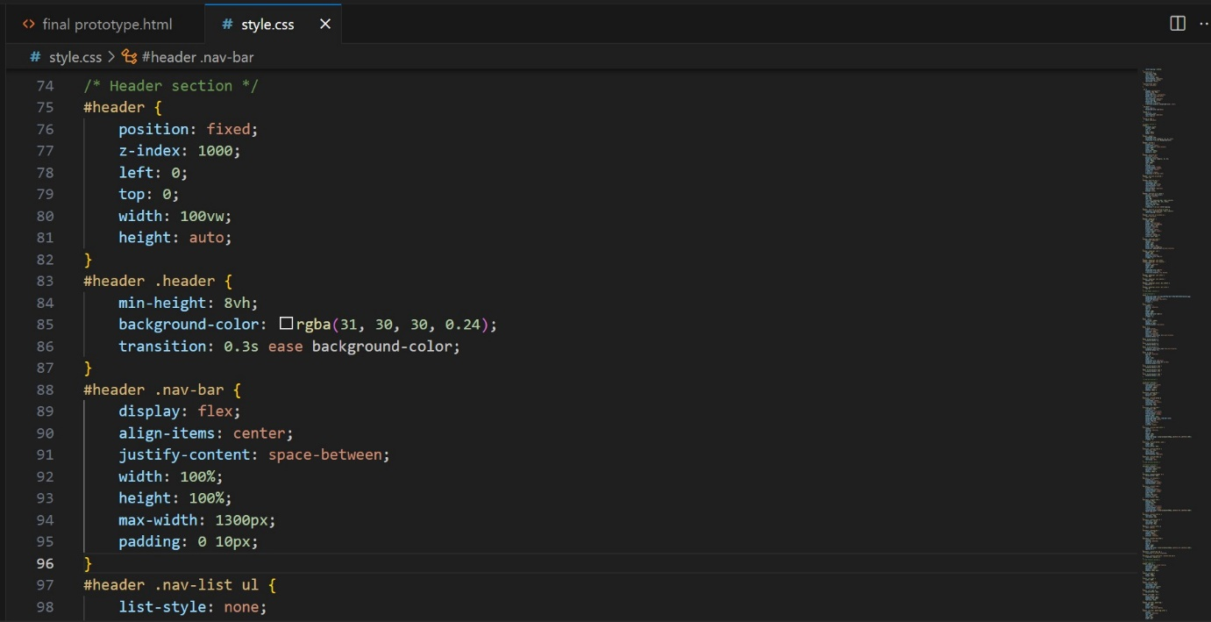

Figure. 3.7 Style.css “header”

**"Embark on an Enlightening Journey through Legal Excellence and Creative Expression: Welcome to**

**My Digital Canvas: An Interactive Portfolio”**

Here, you'll embark on an enlightening journey through the world of legal studies and creative expression. To navigate our site, simply explore the five engaging options: Home, Services, Projects, About, & Contact.

If you're eager to explore my diverse portfolio of legal projects and creative endeavors, start by clicking on "Home" to discover a curated collection that showcases my skills and passions. Learn about my dedication to legal excellence, creative innovation, and the art of storytelling through law.

Ready to engage with my services as a law student and creative thinker? Click on "Services" to explore how I can assist you with legal research, writing, and creative projects. Whether you're seeking assistance with legal documents, academic papers, or creative projects, I'm here to support you on your journey.

Interested in my past projects and collaborations? Click on "Projects" to view a selection of my previous work, including legal research papers, creative writing pieces, and design projects. Dive into the details of each project and gain insights into my skills and expertise.

Curious to know more about the journey that led me to law and creativity? Click on "About" to uncover my personal story and the values that guide me on this intellectual adventure. From my academic achievements to my professional aspirations, I invite you to explore the narrative behind my legal and creative pursuits.

Looking to get in touch? Click on "Contact" to find my contact information and reach out to discuss potential collaborations, projects, or just to say hello. I'm always eager to connect with fellow legal enthusiasts and creative minds.

Join me on a transformative journey where legal education meets creative expression. Together, we will push the boundaries of traditional learning and explore new dimensions of legal understanding and artistic innovation. Begin your exploration today by navigating through my website. Discover a world where legal concepts come to life through creative storytelling and where artistic expression finds its foundation in legal principles.

Whether you are a fellow law student, a legal professional, or simply someone with a passion for creativity and learning, there is something here for you. Dive into the fascinating world of legal studies and creative endeavors, and join me in redefining the way we perceive and engage with the law.

Together, let's embark on a journey of discovery, enlightenment, and creativity. Click your way through my website and open your mind to the endless possibilities that await in the realm of legal education and creative expression.

**SUMMARY**

In this report, I have outlined the fundamental aspects of web development and its key components, focusing on their relevance to "My Digital Canvas: An Interactive Portfolio" as a law student's website. I discussed the different forms of web development and the tools essential for their creation, emphasizing their role in enhancing the user experience and showcasing legal expertise.

Web development encompasses various disciplines, including front-end, back-end, and full-stack development, each requiring distinct skills and resources. Front-end development involves designing the user interface (UI) and user experience (UX) of a website, using languages such as HTML, CSS, and JavaScript to create visually appealing and interactive elements. Back-end development focuses on the server-side of the website, managing data and ensuring smooth functionality. Full-stack developers are proficient in both front-end and back-end development, enabling them to create fully functional and dynamic websites.

For "My Digital Canvas: An Interactive Portfolio," a well-designed and user-friendly interface is crucial to effectively communicate legal knowledge and skills. By utilizing tools and frameworks tailored to legal education and research, the website can showcase a portfolio while providing valuable insights and resources for law students and professionals.

A high-performing and visually appealing website is essential for any business, including law students showcasing their skills and expertise. Attracting visitors and users is central to the website's success, highlighting the importance of skilled website developers in creating a compelling online presence.